$$\boxed{INFLUENCE LINE}$$

The influence line can be constructed by placing the UNIT moving concentrated LOAD at the variable position x, and then computing the function’s value (such as Reaction, shear, or moment) in terms of x.

Example 1: Draw the Influence Line (I.L.) Reaction force at point A. Shear force at point C and moment at point C?
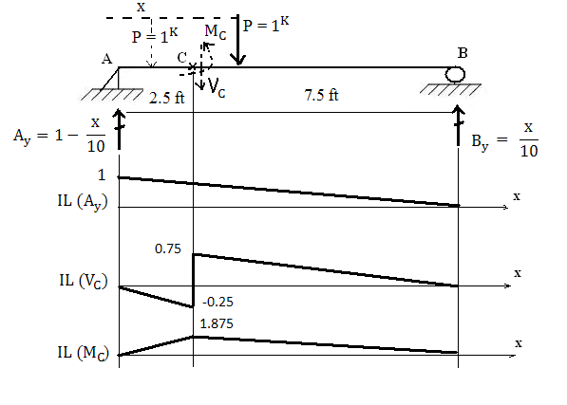
$\sum{M_{@A}= 0^{}= -\left(1^{K}\right)\left(x\right)+ \left(B_{y}\right)\left(10\right)→ }B_{y}= \frac{x}{10}$
$\sum{F_{y}= 0^{↑+}=}A_{y}{+ (B}_{y}= \frac{x}{10})-1^{K}→A_{y}= 1-\frac{x}{10}$

When 0’$≤x≤{2.5}^{ft}; then \sum{F_{y}= 0^{↑+}=}+A_{y}-P-V_{C}→V_{C}= A_{y}-P$ $V_{C}= 1-\frac{x}{10}-1$
When 2.5’$≤x≤{10}^{ft}; then \sum{F_{y}= 0^{↑+}=}A_{y}-V_{C}$ $→V_{C}= A_{y}=1-\frac{x}{10}$
For 0’$≤x≤{2.5}^{'}→\sum{M_{C}= 0^{}= M_{C}+ 1^{K}\left(2.5-x\right)-\left( A_{y}\right)\left(2.5 ft\right)}$
So, $M_{C}=\left(x-2.5\right)+ \left(1-\frac{x}{10} \right)\left(2.5 ft\right)=0.75x$
For 2.5$≤x≤10→\sum{M_{C}= 0_{ = }^{} M_{C}- \left(1-\frac{x}{10}\right)\left(2.5 \right)}$
So, $M_{C}=2.5-0.25x$

$$\boxed{INFLUENCE LINE FOR MOVING UNIFORM LOAD}$$

- Assuming the Influence Line (I.L) for a unit, moving concentrated load (P = $1^{K})$for the function ‘y’ (such as Reaction, shear force, or moment at certain point) has already been computed and plotted.

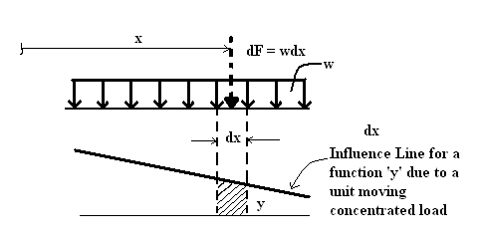
- Then, the influence line for a moving uniform load ($w^{K/in)}$ can be derived as following:

- The value of the function due to a concentrated force $dF$ would be: $y*(dF=wdx)$

- Hence, the value of function due to Entire Uniform Load ( = summation of all $dF$ point loads) would be : $\int{y*(dF=wdx)}$
Or, $w*\int{ydx ≡w*[Area under I.L.]}$

Example 2: Draw the I.L. for reaction force $A_{y}$ of the following beam.

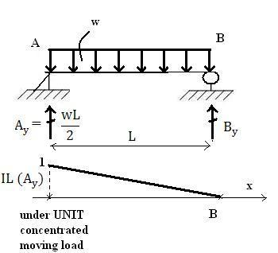

Area (under I.L. for $A_{y})= \frac{1}{2}*1*L= \frac{L}{2}$
Thus, I.L. for $A_{y}$ (under uniform load) = $w*\left[Area\right]=w* \frac{L}{2}$

Example 3: Find the maximum positive ‘live load’ shear that can be developed at point C for the beam shown, due to a concentrated live load of${ 4, 000}^{lbs}$, and a uniform live load of
$w_{L }= {2,000}^{lbs}$

Solution:
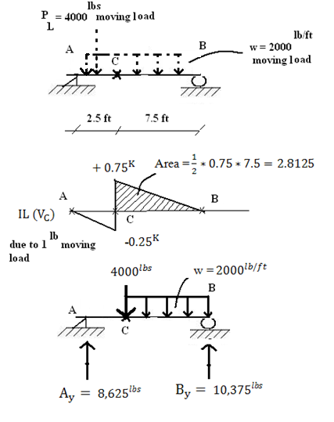

- Consider concentrated moving load ($P_{L}=4000^{lbs}).$The maximum positive shear force $V_{C}$ developed at point C will occur when $P_{L}$ is applied at point C.
- Consider uniform moving load${(w}_{L }= {2,000}^{lbs})$. The uniform live load will create max., positive shear for $V_{C}$ when this uniform load act in the region CB.
Thus: $\left(V_{C}^{+})_{max}= {(w}_{L}= {2000}^{lbs}\right)*\left[Area=2.8125\right]=5625^{lbs}$
- Finally, $\left({(V}_{C}^{+})_{max}= {3000}^{lbs}+5625^{lbs}\right)=\boxed{8625^{lbs}}$

